**A**

**Project**

**On**

**“Stock Academy”**

**Submitted to**

**Shiksha Mandal’s**

**G. S. COLLEGE OF COMMERCE & ECONOMICS, NAGPUR**

**(AUTONOMOUS)**

**In the Partial Fulfillment of**

**B.Com. (Computer Application) Final Year**

**Submitted by**

**Seema patel**

**Urvashi pawar**

**Under the Guidance of**

**Pravin J. Yadao**



**Shiksha Mandal’s**

**G. S. COLLEGE OF COMMERCE & ECONOMICS, NAGPUR**

**AUTONOMOUS**

**2023-2024**

**ShikshaMandal’s**

**G. S. COLLEGE OF COMMERCE & ECONOMICS, NAGPUR**

**(AUTONOMOUS)**

CERTIFICATE

**(2022 - 2023)**

**This is to certify that Miss Seema patel and Miss Urvashi Pawar have completed their project on the topic of “STOCK ACADEMY” prescribed by G. S. College of Commerce & Economics, Nagpur (Autonomous) for B.Com. (Computer Application) – Semester-VI.**

**Date:**

**Place: Nagpur**

**Pravin J. Yadao**

**Project Guide**

**External Examiner Internal Examiner**

**ACKNOWLEDGEMENT**

We take this opportunity to express our deep gratitude and wholehearted thanks to project guide Prof. Pravin Yadao, Coordinator for his guidance throughout this work. We are very much thankful to him for his constant encouragement, support, and kindness.

We are also grateful to our teachers Prof. Rahul Tiwari, Prof. Sushma Gawande, Prof. Preeti Nandurkar, Prof. Prajkta Deshpande, and Prof. Haresh Naringe for their encouragement, help, and support from time to time.

We also wish to express our sincere thanks to Principal Dr. Pravin Mustoor for providing us with a wide range of opportunities, facilities, and inspiration to gather professional knowledge and material without which this project could not have been completed.

Seema Patel

Urvashi Pawar

Date:

Place: Nagpur

**DECLARATION**

We Seema Patel & Urvashi Pawar hereby honestly declare that the work entitled **“STOCK ACADEMY”** submitted by us at G. S. College of Commerce & Economics, Nagpur (Autonomous) in partial fulfillment of the requirement for the award of B.Com. (Computer Application) degree by Rashtrasant Tukadoji Maharaj, Nagpur University, Nagpur has not been submitted elsewhere for the award of any degree, during the academic session 2023-2024.

The project has been developed and completed by us independently under the supervision of the subject teacher and project guide.

Seema Patel

Urvashi Pawar

Date:

Place: Nagpur

**INDEX**

|  |  |  |  |
| --- | --- | --- | --- |
| **Sr.No.** | **Project Report Format** | **Page No.** | **Remark/Sign** |
| **1.** | **Introduction** |  |  |
| **2.** | **Objectives** |  |  |
| **3.** | **Preliminary System Analysis**   * 1. **Preliminary Investigation**   2. **Flaws in the present system**   3. **Need for a new system**   4. **Feasibility study** |  |  |
| **4.** | **Project Category** |  |  |
| **5.** | **Software and Hardware Specification Requirements** |  |  |
| **6.** | **Detailed System Analysis**  **Data Flow Diagram**  **Data structure and tables** |  |  |
| **7.** | **System Design**   * 1. **Form design**   2. **Source code**   3. **Input and output screens** |  |  |
| **8.** | **Testing and validation checks** |  |  |
| **9.** | **System Security Measures** |  |  |
| **10.** | **Implementation, Evaluation, and Maintenance** |  |  |
| **11.** | **Future Scope of the project** |  |  |
| **12.** | **Conclusion** |  |  |
| **13.** | **Bibliography and Reference** |  |  |

**INTRODUCTION**

**INTRODUCTION**

Our project Title is “Stock Analysis Pro”. This project is based on providing the knowledge. The stock market is a complex system, but understanding its basic functions can open doors to exciting investment opportunities. In essence, it's a marketplace where companies (issuers) can raise capital by selling shares of ownership (stocks) to investors. These investors buy stocks hoping the company's value will increase, allowing them to sell their shares later for a profit.

There are two main ways to participate in the stock market: buying stocks and holding them for long-term growth (capital appreciation), or buying and selling stocks frequently to capitalize on short-term price movements (active trading). Each approach carries its own risks and rewards, and careful research is crucial for success.

Investing in the stock market can be a powerful tool for building wealth over time, but it's important to remember that it's not without risks. Stock prices can go down as well as up, and investors can potentially lose money. Before diving in, it's essential to educate yourself, understand your risk tolerance, and develop a sound investment strategy.

This is just a basic introduction. There's a wealth of information available online and through financial institutions to help you delve deeper. Consider exploring resources like investment guides, financial news outlets, and educational platforms offered by reputable brokerages. Remember, responsible investing is key – knowledge is power, and the stock market is no exception.

Stock exchanges, like the New York Stock Exchange (NYSE) or the NASDAQ , are the designated platforms where buying and selling occur. Investors place orders through brokers, who act as intermediaries to execute trades on the exchange. Prices fluctuate throughout the day based on supply and demand. When there are more buyers than sellers, the price goes up. Conversely, if there are more sellers than buyers, the price goes down.

There are many resources available online and through libraries to understand basic investment principles. Consider your financial goals and risk tolerance before investing, and consult with a financial advisor for personalized guidance. Provides a free online course titled "Financial Markets." While it covers more than just stocks, it offers a well-structured introduction to investing fundamentals

**OBJECTIVES**

**OBJECTIVES:-**

**1. Fundamental Concepts:**

* Understanding the basic terminology of the stock market such as stocks, bonds, mutual funds, indices, etc.
* Grasping the concept of supply and demand and its impact on stock prices.
* Explaining the role of exchanges and regulatory bodies in the stock market.

**2. Market Analysis**:

* Teaching various methods of stock market analysis including fundamental analysis, technical analysis, and sentiment analysis.
* Demonstrating how to interpret financial statements and company reports.
* Introducing different chart patterns and indicators used in technical analysis.

**3. Investment Strategies:**

* Explaining different investment strategies such as value investing, growth investing, dividend investing, etc.
* Discussing the importance of asset allocation and diversification.
* Introducing risk management techniques and tools.

**4. Risk Management:**

* Understanding risk-return tradeoffs.
* Teaching how to calculate and manage risk through techniques such as stop-loss orders and position sizing.
* Discussing the importance of maintaining a disciplined approach to investing and trading.

**5. Case Studies and Examples:**

* Using real-life case studies and examples to illustrate key concepts.
* Analyzing historical market events and their impact on investments.
* Encouraging critical thinking and problem-solving skills through practical applications.

**6. Regulatory Environment:**

* Providing an overview of securities regulations and laws.
* Explaining the role of regulatory bodies such as the Securities and Exchange Commission (SEC) and Financial Industry Regulatory Authority (FINRA).
* Discussing the importance of ethical conduct in the stock market.

**7. Risk Management Strategies:**

Offer resources and educational content on risk management strategies in the stock market. This could include information on stop-loss orders, diversification, and hedging techniques

**8. Long-Term Perspective:** The stock market can be volatile, and education emphasizes the importance of a long-term approach to investing for sustainable wealth creation. While a long-term perspective is essential, it doesn't mean completely ignoring short-term factors. Staying informed about major economic events and company news can still be valuable.

**9 . Contributor to Economic Growth:** Stock exchange offers a platform for trading of securities of the various companies. This process of trading involves continuous disinvestment and reinvestment, which offers opportunities for capital formation and subsequently, growth of the econo

**PRELIMINARY**

**SYSTEM ANALYSIS**

### PRELIMINARY SYSTEM ANALYSIS

**PRELIMINARY INVESTIGATION**

**1. Gain Basic Knowledge:** Before delving into investment endeavors, it's crucial to acquire a fundamental understanding of financial markets, investment instruments, and various strategies. This includes comprehending concepts like diversification, asset allocation, fundamental and technical analysis, and the role of economic indicators. Educating oneself through resources such as books, online courses, or seeking guidance from financial advisors can lay a solid foundation.

**2. Develop a Strategy:** Once equipped with basic knowledge, investors can develop a strategy tailored to their specific goals, risk tolerance, and time horizon. Strategies may include long-term investing in stocks for capital appreciation, dividend investing for regular income, or a combination of different asset classes such as equities, bonds, and real estate to achieve diversification and risk mitigation.

**3. Market Terminology:** Understanding market terminology is essential for effective communication and decision-making in the investment landscape. Key terms include bull and bear markets, P/E ratio (Price-to-Earnings ratio), EPS (Earnings Per Share), dividends, market capitalization, and various order types such as market orders, limit orders, and stop-loss orders.

**4. Assess Risk Tolerance:** Risk tolerance refers to an investor's ability to endure fluctuations in the value of their investments without feeling compelled to sell during market downturns. It's crucial to assess one's risk tolerance accurately, considering factors such as age, financial obligations, investment goals, and psychological temperament. Risk tolerance often influences asset allocation decisions, with more risk-averse investors opting for a higher allocation to fixed-income securities, while those comfortable with volatility may allocate more to equities.

**5. Stock Market Mechanics:** Understanding the mechanics of the stock market involves grasping how securities are traded, price determination mechanisms, and the role of various participants such as investors, brokers, market makers, and regulatory bodies. This includes understanding the primary and secondary markets, stock exchanges, trading hours, and factors influencing stock prices such as company performance, economic indicators, and geopolitical events. Additionally, comprehending technical aspects like bid-ask spreads, trading volumes, and market liquidity is crucial for executing trades effectively and understanding market dynamics.

**6. Identify Investment Goals:** Investment goals in the stock market can vary widely depending on individual preferences, risk tolerance, and financial objectives. However, there are some common investment goals that many investors pursue when entering the stock market. One primary goal is capital appreciation, which involves aiming to grow the value of one's investments over time. Investors seeking capital appreciation are typically focused on selecting stocks with high growth potential, often in industries or sectors poised for significant expansion. They may prioritize companies with innovative products or services, strong competitive advantages, and robust financial performance metrics.

**FLAWS IN SYSTEM**

These pitfalls involves mindfulness, education, and a willingness to learn from mistakes. By recognizing and actively working to overcome these challenges, individuals can improve their decision-making processes and achieve greater success in various aspects of life.

**1. Ignoring Risk Management:** This refers to not considering or adequately addressing potential risks associated with a decision or action. In finance, for example, it could mean investing without diversifying one's portfolio or not having a backup plan in place.

**2 .Short-term Focus:** This is the tendency to prioritize immediate results or gains over long-term benefits or sustainability. It can lead to impulsive decision-making and overlooking the bigger picture.

**3. Not Understanding the Basics:** This involves lacking fundamental knowledge or skills relevant to a particular field or activity. Without a solid understanding of basics, it's challenging to build upon that knowledge or make informed decisions.

**4. Lack of Research:** Making decisions without conducting thorough research or gathering sufficient information can lead to poor outcomes. Whether it's investing in a stock, choosing a career path, or making a major purchase, research helps mitigate risks and ensures informed choices.

**5. Overconfidence:** Being overly confident in one's abilities or judgments can lead to ignoring warning signs, underestimating risks, or making reckless decisions. It's essential to maintain a healthy level of skepticism and humility to avoid this pitfall.

**6 . Lack of Patience:** Impatience can lead to seeking quick fixes or instant gratification, often at the expense of long-term goals or success. Developing patience allows for persistence, strategic planning, and staying focused on the bigger picture.

**NEED FOR A NEW SYSTEM**

**1 Understand the Basics:** This refers to having a foundational understanding of the subject matter at hand. Whether it's finance, programming, or any other field, grasping the basics is essential before delving deeper into more complex topics. For example, in finance, understanding basic concepts such as assets, liabilities, income statements, and balance sheets is crucial before moving on to more advanced topics like derivatives or financial modeling.

**2. Study Fundamental Analysis:** Fundamental analysis is a method used to evaluate the intrinsic value of a stock by examining related economic, financial, and other qualitative and quantitative factors. This analysis involves studying a company's financial statements, management team, industry conditions, and economic indicators to determine whether a stock is undervalued or overvalued. Fundamental analysts believe that the market may misprice a stock in the short term, but in the long run, its price will reflect its true value.

**3. Explore Sentiment Analysis:** Sentiment analysis, also known as opinion mining, is the process of analyzing text data to determine the sentiment expressed within it. In the context of financial markets, sentiment analysis involves analyzing news articles, social media posts, and other sources of information to gauge market sentiment, which can influence stock prices and market trends. By understanding whether sentiment is positive, negative, or neutral, traders and investors can make more informed decisions about buying or selling assets.

**4. Practice Paper Trading:** Paper trading, also known as virtual trading or simulated trading, is a method of practicing trading strategies without risking real money. It involves using a simulated trading account that replicates the functions of a real trading account but uses virtual money instead. Paper trading allows individuals to test out different trading strategies, learn how financial markets work, and gain experience in executing trades without the potential for financial loss. It's a valuable tool for both novice and experienced traders to refine their skills and build confidence before committing real capital to the market.

**FEASIBILITY STUDY**

A feasibility study for beginners in stock analysis involves assessing whether learning about stock analysis is viable and practical for individuals who are new to the subject. define the objectives of learning stock analysis. Are you aiming to gain a basic understanding for personal investment purposes, or are you considering a career in finance . Research the demand for stock analysis skills. Look into job market trends, the prevalence of online courses, and the availability of resources for beginners. Assess the competition and identify key players in the industry.

**Types of Feasibility Study:**

In the context of beginner stock analysis study materials, feasibility studies can be approached from different angles to ensure that the chosen study materials are suitable and effective. Here are several types of feasibility studies relevant to beginner stock analysis study materials.

**1. Technical Feasibility:** This aspect examines whether the technology required for stock analysis or study material creation is available, accessible, and capable of meeting the project's requirements. It involves assessing factors such as the availability of data sources, computational resources, analytical tools, and any necessary software or hardware. For instance, a technical feasibility assessment might involve determining whether the chosen analysis platform can handle the volume of data required for comprehensive stock analysis or if the study material creation tools are compatible with the intended distribution channels.

**2. Financial Feasibility:** Financial feasibility evaluates whether the resources required for conducting stock analysis or creating study material are available and justifiable within the project's budget constraints. This includes considerations such as the costs associated with acquiring data, tools, expertise, and any other resources needed. For stock analysis, it also involves assessing potential returns on investment and considering the revenue-generating potential of the analysis. In the case of study material creation, financial feasibility may involve estimating production costs, distribution expenses, and potential revenue streams from sales or subscriptions.

**3. Operational Feasibility:** Operational feasibility examines whether the processes and procedures required for conducting stock analysis or producing study material are practical and sustainable within the existing organizational or operational framework. It involves assessing factors such as the availability of skilled personnel, logistical considerations, workflow efficiency, and potential disruptions or bottlenecks. For stock analysis, operational feasibility might involve evaluating the ease of data collection, analysis methodologies, and reporting mechanisms. In the context of study material creation, it may include considerations such as content development workflows, editing processes, and quality assurance measures.

**4. Content Feasibility:** Content feasibility assesses whether the information and insights generated through stock analysis or included in study material are accurate, relevant, and valuable to the target audience. It involves evaluating the comprehensiveness, credibility, and timeliness of the content. For stock analysis, content feasibility may involve verifying the accuracy of financial data, the validity of analytical models, and the relevance of insights to investors or stakeholders. In study material creation, it includes ensuring that the content aligns with educational objectives, covers essential topics adequately, and presents information in a clear and engaging manner.

**5. Time Feasibility:** Time feasibility evaluates whether the stock analysis or study material creation can be completed within the allotted timeframe or desired schedule. It involves estimating the duration of each phase of the project, identifying critical milestones, and assessing potential delays or constraints. For stock analysis, time feasibility may involve considering factors such as data collection periods, analysis timelines, and reporting deadlines. In the case of study material creation, it includes content development, editing, formatting, and distribution schedules.

**6. Market Feasibility:** Market feasibility examines the demand, competition, and potential acceptance of the stock analysis or study material within the target market or audience. It involves assessing factors such as market trends, customer preferences, competitor offerings, and regulatory considerations. For stock analysis, market feasibility may involve identifying investor preferences, analyzing market dynamics, and evaluating demand for specific types of analysis or insights. In study material creation, it includes researching educational needs, identifying niche markets, and understanding the competitive landscape within the educational content space.

**PROJECT**

**CATEGORY**

##### PROJECT CATEGORY

The project falls under the category of full-stack web form applications. In our project, we have used the HTML Markup Language VS-Code for the Front End and Backend.

**PROGRAMMING LANGUAGES USED IN THE PROJECT**

**HTML (Markup Language)**

HTML (Hypertext Markup Language) is a markup language used for creating web pages and other information that can be displayed in a web browser. HTML uses tags and attributes to describe the content and structure of a web page, including headings, paragraphs, lists, tables, images, links, forms, and multimedia elements.

HTML documents are composed of two main parts: the head and the body. The head contains information about the document, such as the title, keywords, and other metadata, while the body contains the content that is displayed in the web browser.

HTML is a widely used technology and is essential for creating and publishing web pages on the internet. Web developers and designers use HTML along with CSS (Cascading Style Sheets) and JavaScript to create interactive and dynamic web pages that are accessible to a wide range of devices and users.

##### USES OF HTML

 Creating web pages

 Designing email Newsletters

 Developing Mobile Applications

 Creating e-books

 Developing Web Based Games

##### ADVANTAGES OF HTML

* Easy to learn & use
* Customization
* Platform Independent
* Fast loading
* Accessibility
* Browser Compatibility

##### DISADVANTAGES OF HTML

* Maintenance Issues
* Security Vulnerabilities
* Lack of compatibility with older browser
* Limited Functionality
* Designing limitations

##### CSS (Cascading Style Sheets)

Cascading Style Sheets, fondly referred to as CSS, is a simply designed language intended to simplify the process of making web pages presentable. CSS allows you to apply styles to web pages. More importantly, CSS enables you to do this independent of the HTML that makes up each web page.CSS is easy to learn and understood, but it provides powerful control over the presentation of an HTML document.

**C**ascading **S**tyle **S**heets, fondly referred to as **CSS**, is a simply designed language intended to simplify the process of making web pages presentable. CSS allows you to apply styles to web pages. More importantly, CSS enables you to do this independent of the HTML that makes up each web page. CSS is easy to learn and understood, but it provides powerful control over the presentation of an HTML document.

A CSS comprises style rules that are interpreted by the browser and then applied to the corresponding elements in your document. A style rule set consists of a selector and declaration block.

There are three types of CSS which are given below:

* Inline CSS
* Internal or Embedded CSS
* External CSS

**Properties:**

CSS uses various properties to enhance the presentation of results. These properties are background, border, font, float, display, margin, opacity, padding, text-align, vertical-align, position, color etc.

**SYNTAX:**

**1 . Inline CSS:**

An inline style may be used to apply a unique style for a single element.

To use inline styles, add the style attribute to the relevant element. The style attribute can contain any CSS property.

**Example:**

<!DOCTYPE html>  
<html>  
<body>  
  
<h1 style="color:blue;text-align:center;">This is a heading</h1>  
<p style="color:red;">This is a paragraph.</p>  
  
</body>  
</html>

**2. Internal or Embedded CSS:**

An internal style sheet may be used if one single HTML page has a unique style.

The internal style is defined inside the <style> element, inside the head section.

**Example:**

**<!DOCTYPE html>**

**<HTML>**

**<HEAD>**

**<!-- Head section of web page -->**

**<TITLE></TITLE>**

**<!-- Stylesheet of web page -->**

**<STYLE></STYLE>**

**</HEAD>**

**3. External CSS:**

external style sheet, you can change the look of an entire website by changing just one file .

Each HTML page must include a reference to the external style sheet file inside the <link> element, inside the head section.

**<!DOCTYPE html>  
<html>  
<head>  
<link rel="stylesheet" href="mystyle.css">  
</head>  
<body>  
  
<h1>This is a heading</h1>  
<p>This is a paragraph.</p>  
  
</body>  
</html>**

##### JAVASCRIPT

JavaScript is a programming language used to create dynamic and interactive web pages. It is often referred To as the "language of the web" because it is supported by all modern web browsers and is widely used for client-side scripting.

JavaScript was originally created to add interactivity to static HTML pages by allowing developers to write scripts that could manipulate the Document Object Model (DOM), which represents the structure of an HTML page. With JavaScript, developers can create animations, validate forms, build interactive user interfaces, and perform other actions on the client-side of a web application.

JavaScript is a high-level, interpreted language, which means that it is designed to be easy to read and write, and it is executed directly by the web browser, without the need for compilation. JavaScript supports a variety of programming paradigms, including object-oriented, functional, and procedural programming.

JavaScript is also commonly used on the server-side through the use of frameworks such as Node.js. With Node.js, developers can use JavaScript to build fast and scalable web applications that run on the server-side.

Overall, JavaScript is a powerful and versatile programming language that plays a critical role in modern web development. It is essential for building dynamic and interactive web pages and is widely used in both client-side and server-side envelopment.

**PHP(Personal Home Page):-**

PHP means – Personal Home Page, but it now stands for the recursive backronym PHP: Hypertext Preprocessor. PHP code may be embedded into HTML code, or it can be used in combination with various web template systems, web content management system and web frameworks. A PHP file can also contain tags such as HTML and client side scripts such as JavaScript. .HTML is an added advantage when learning PHP Language. You can even learn PHP without knowing HTML but it’s recommended you at least know the basics of HTML. • Database management systems DBMS for database powered applications. • For more advanced topics such as interactive applications and web services, you will need JavaScript and XML.

PHP (Hypertext Preprocessor) is a free, open-source scripting language used for web development. It's primarily used for server-side scripting, but can also be used for command-line scripting and desktop applications. PHP can output HTML, images, PDF files, XHTML, and XML. It runs on various platforms, including Windows, Linux, Unix, and Mac

###### **MySQL:**

- • MySQL is a database system used for developing web-based software applications.

* MySQL used for both small and large applications.
* MySQL is a relational database management system (RDBMS).
* MySQL is fast, reliable, and flexible and easy to use.
* MySQL supports standard SQL (Structured Query Language).
* MySQL is free to download and use.
* MySQL was developed by Michael Widenius and David Axmark in 1994.
* MySQL is presently developed, distributed, and supported by Oracle Corporation.
* MySQL Written in C, C++.

###### **Features of MySQL-**

* MySQL server design is multi-layered with independent modules.
* MySQL is fully multithreaded by using kernel threads. It can handle multiple CPUs if they are available.
* MySQL provides transactional and non-transactional storage engines.
* MySQL has a high-speed thread-based memory allocation system.
* MySQL supports in-memory heap table.
* MySQL Handles large databases.
* MySQL Server works in client/server or embedded systems.
* MySQL Works on many different platforms

**SOFTWARE AND HARDWARE**

**REQUIREMENT SPECIFICATION**

##### SOFTWARE NEEDED

Software is a set of instructions, data or programs used to operate computers and execute specific tasks. It is the opposite of hardware, which describes the physical aspects of a computer. Software is a generic term used to refer to applications, scripts and programs that run on a device.

**The Software required to develop the website are as follows:**

**Front End** –

* HTML (Markup Language)
* CSS (Cascading Style Sheet)

**Backend**-

* PHP

**IDE USED-**

* VS-CODE
* Version:- VSCodeUserSetup-x64-1.86.2

##### HARDWARE NEEDED

Hardware refers to the computer's tangible components or delivery systems that store and run the written instructions provided by the software. The software is the intangible part of the device that lets the user interact with the hardware and command it to perform specific tasks.

**The Hardware required to develop the website are as follows:**

Device Name:-DELL LATTITUDE

Proccessor:-Intel(R) Core(TM)Intel® Core™ i7-3520M × 4

RAM:-8.00 GB

Networking:-WiFi adaptor and active internet connection.

**DETAILED SYSTEM ANALYSIS**

##### DETAILED SYSTEM ANALYSIS

##### DATA FLOW DIAGRAM

**Stock Academy**

**Feedback form**

**Database**

**Structure of Website:**

**Stock Academy**

Educational

Case Studies

About Us

Home

Feedback

Level 2

Level 3

Level 1

**DATA STRUCTURE AND TABLE:**

# 

# SYSTEM DESIGN

##### FORM DESIGN:

**1.Home Page:**

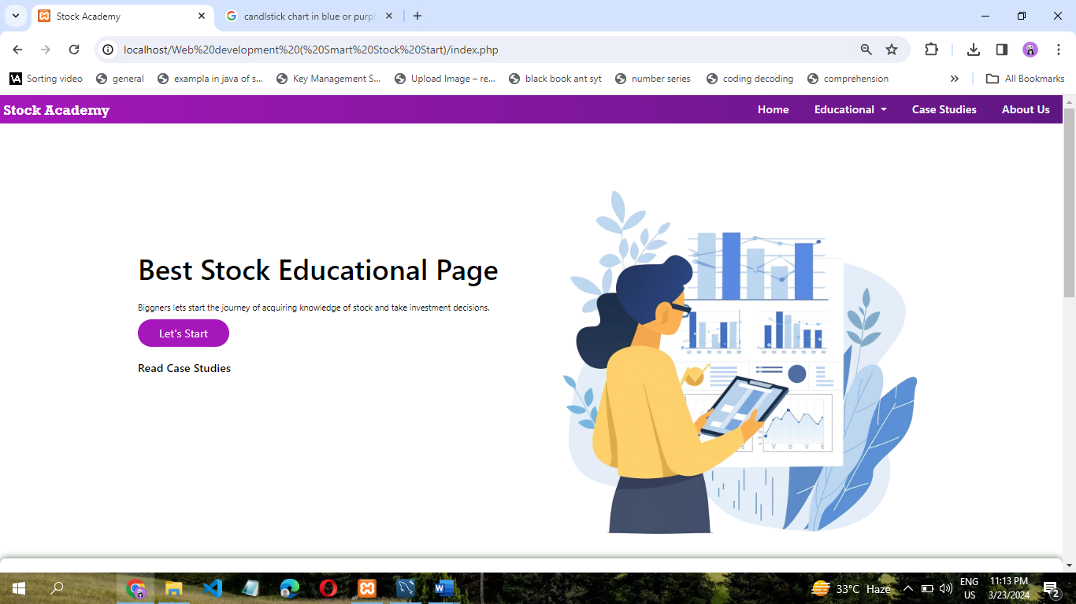

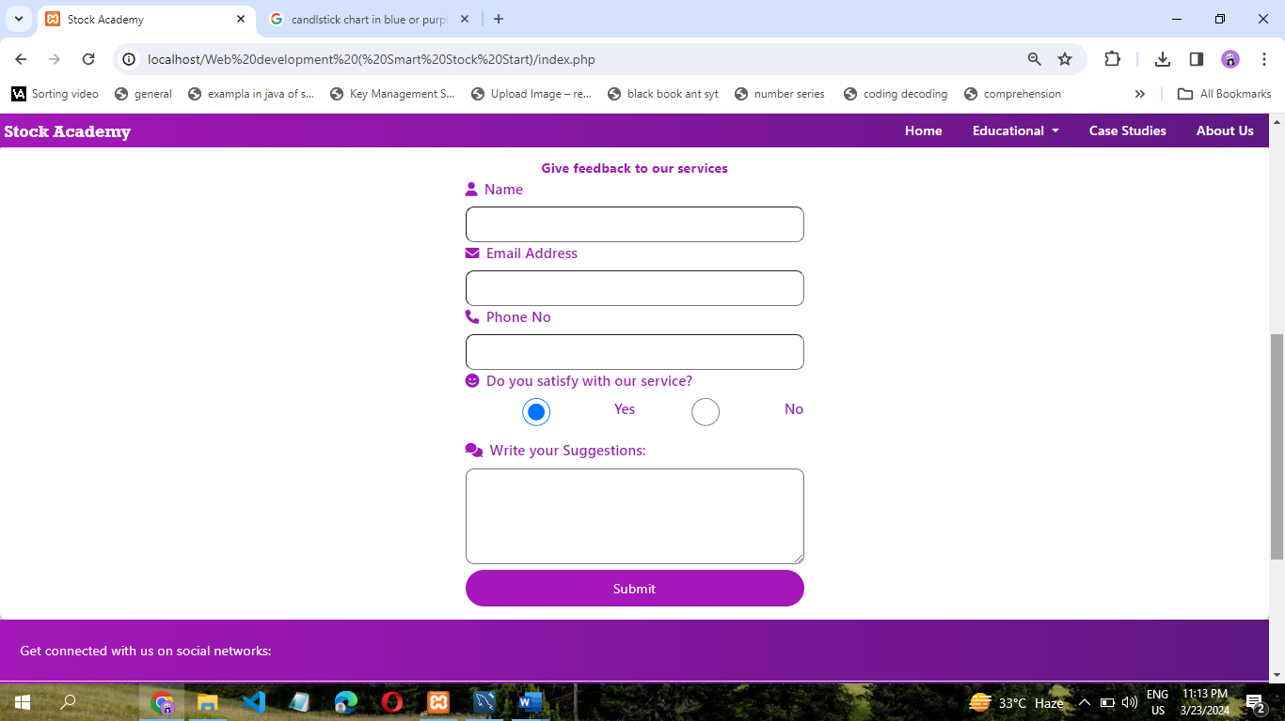

**2. Educational Page:**

**Level 1 Page:**

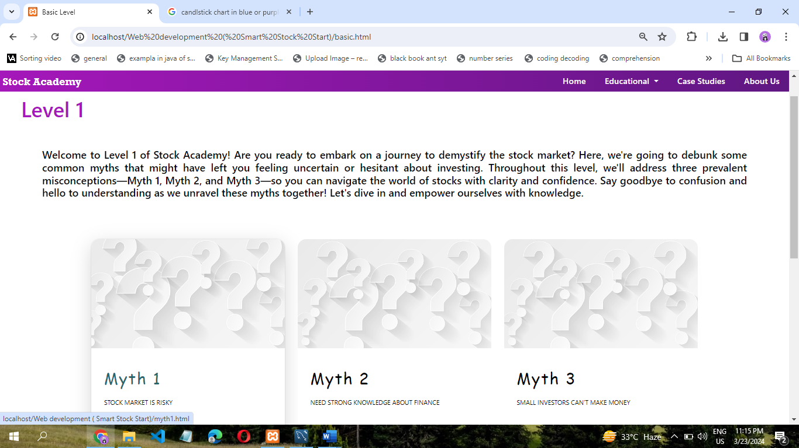

**Myth 1 Page:**

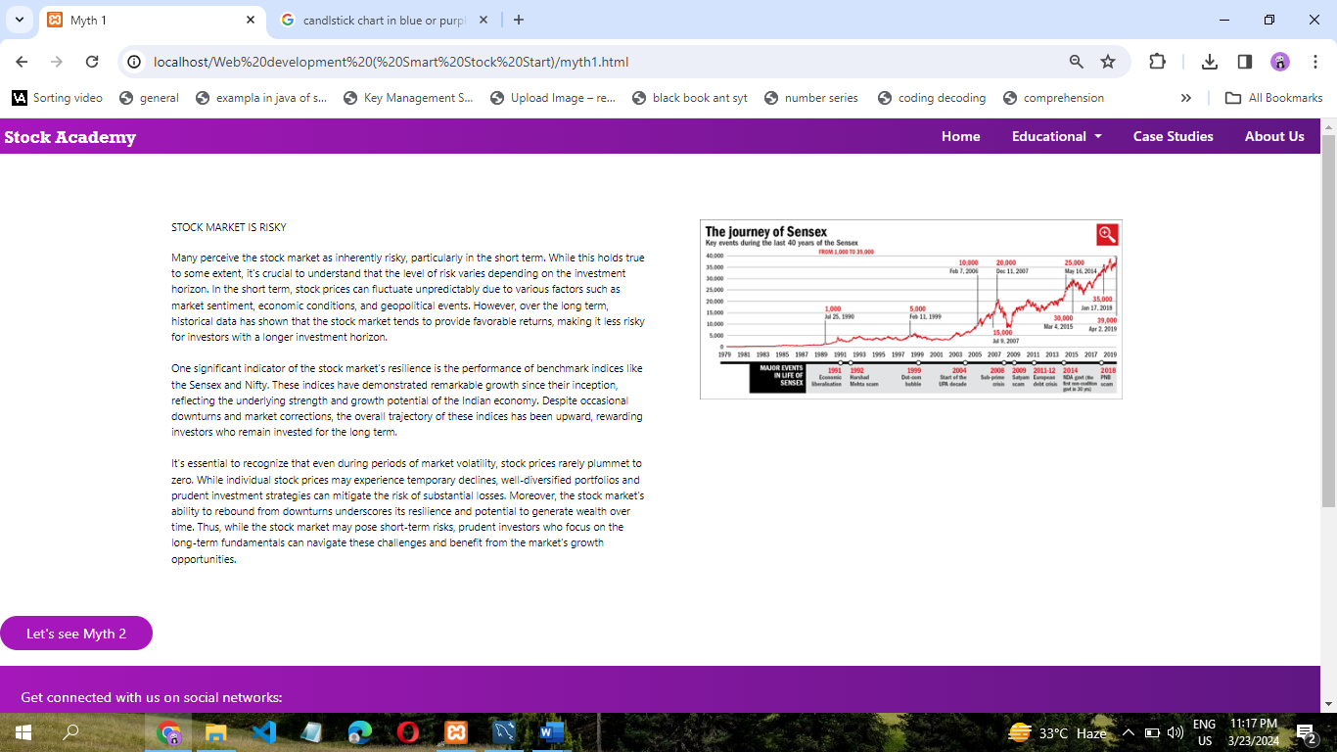

**Myth 2 Page:**

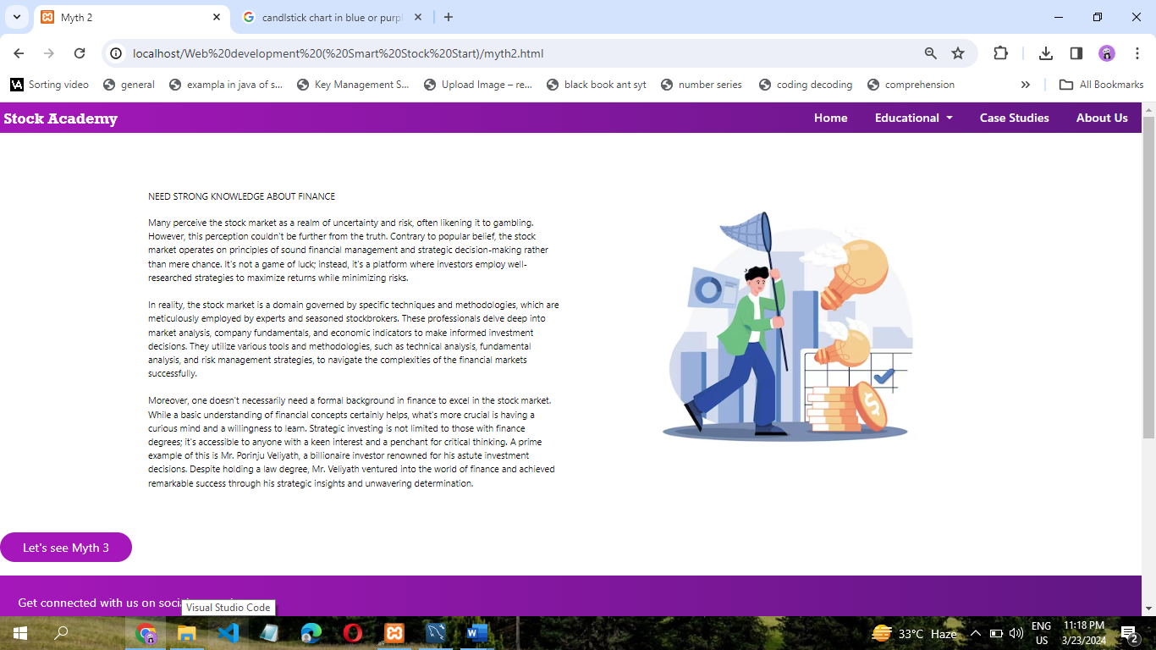

**Myth 3 Page:**

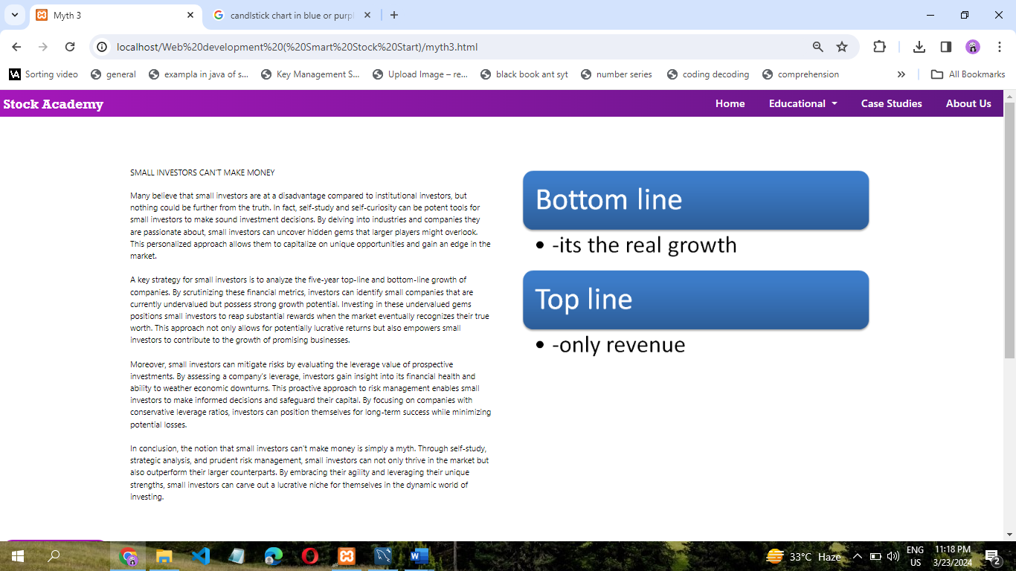

**Level 2 Page:**

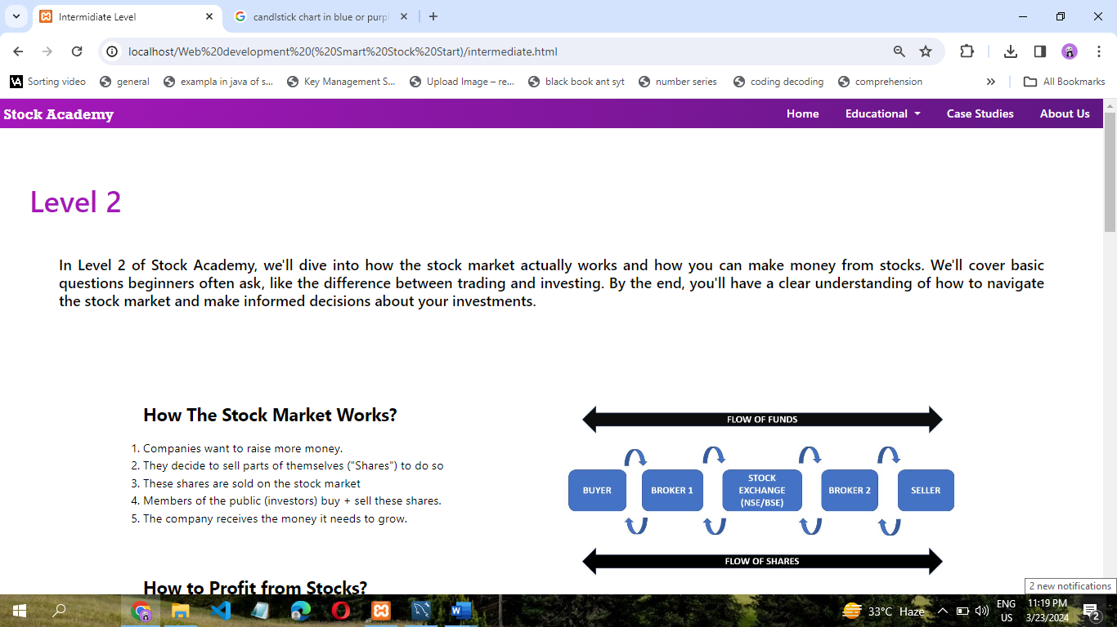

**Level 3 Page:**

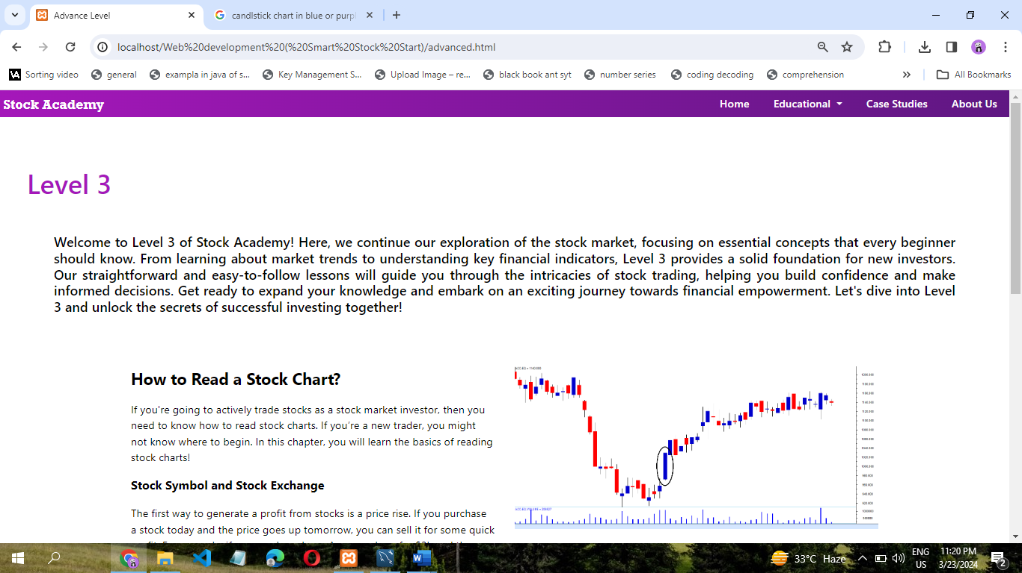

**3. Case Studies Page:**

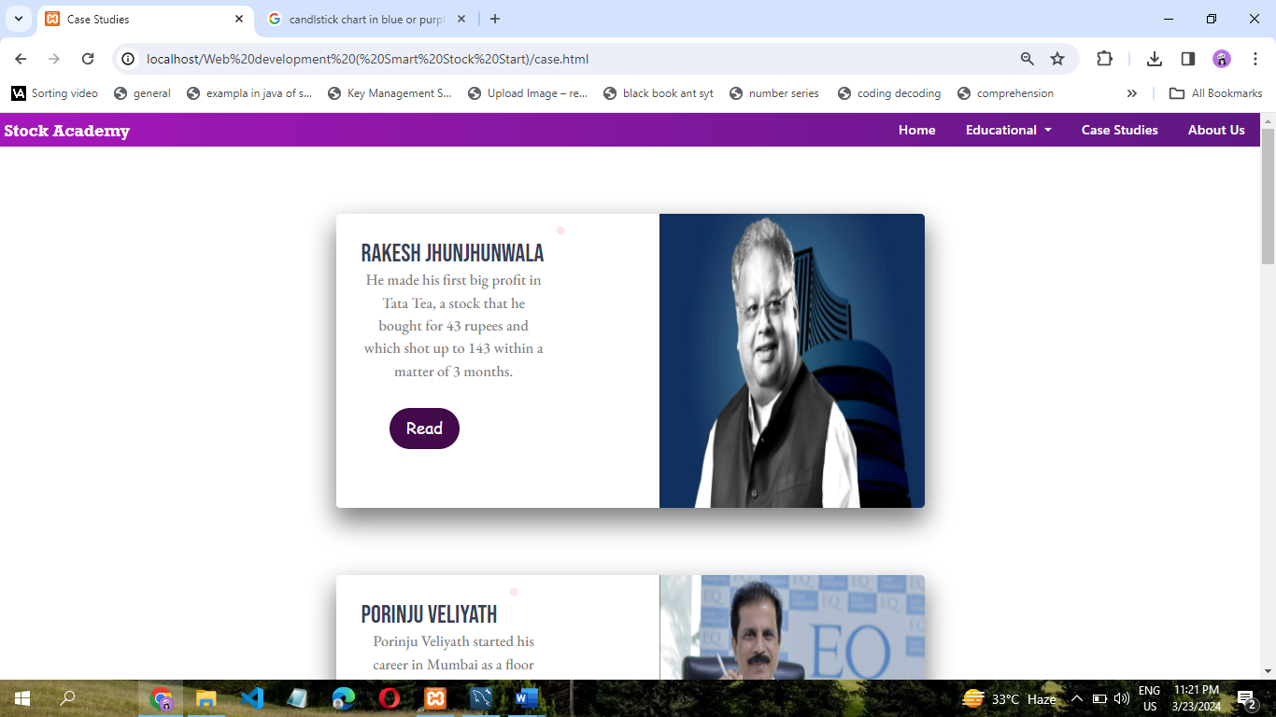

**Rakesh Jhunjunwala Page:**

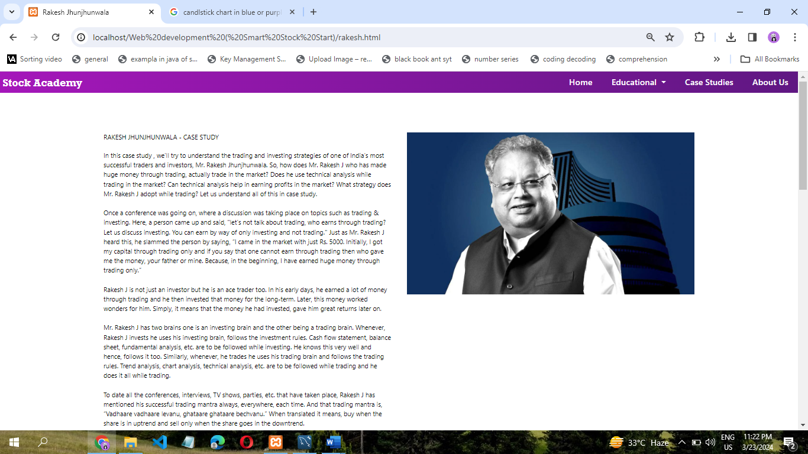

**Porinju Veliyath Page:**

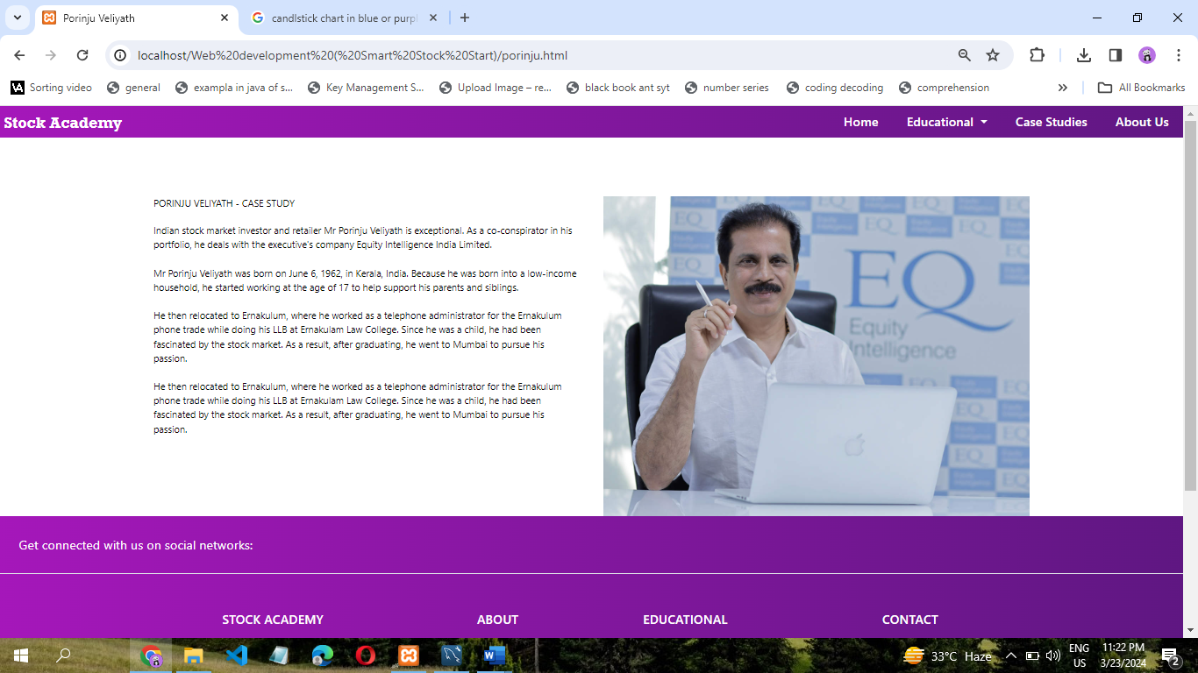

**Motilal Oswal Page:**

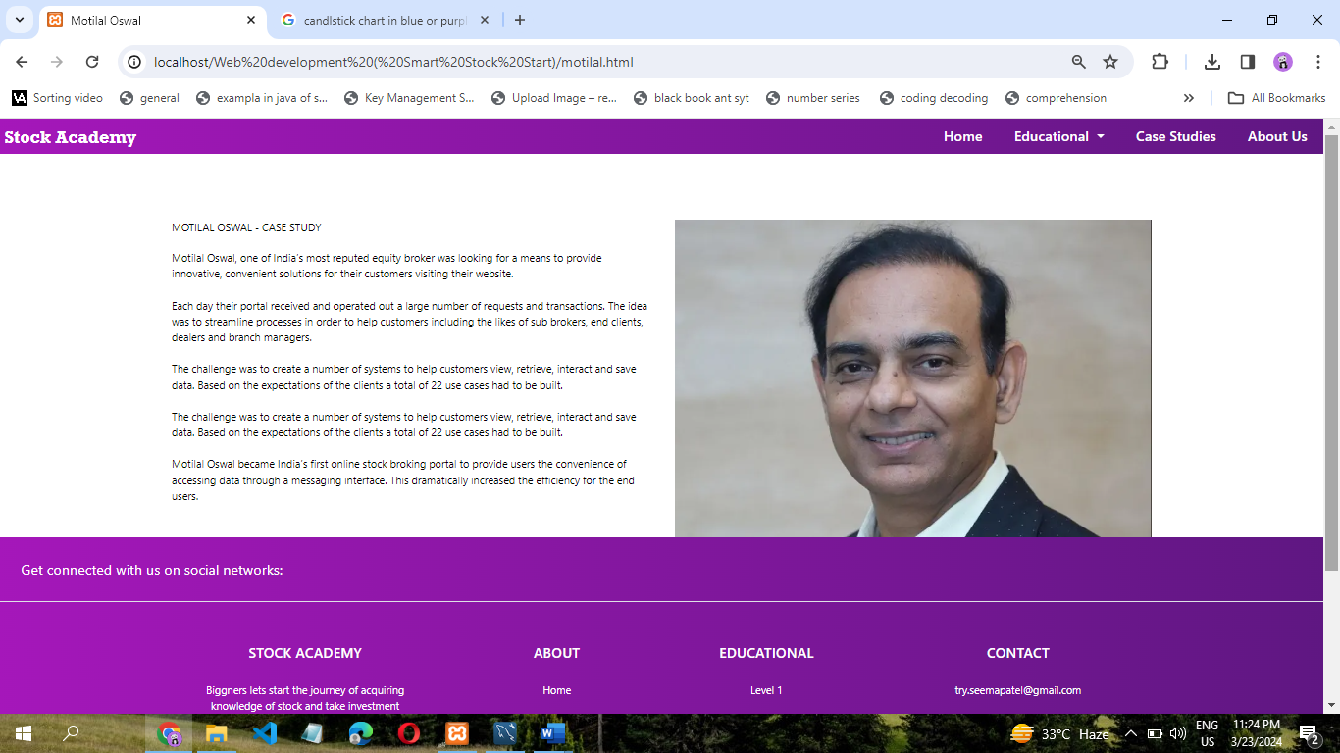

**Parag Parekh Page:**

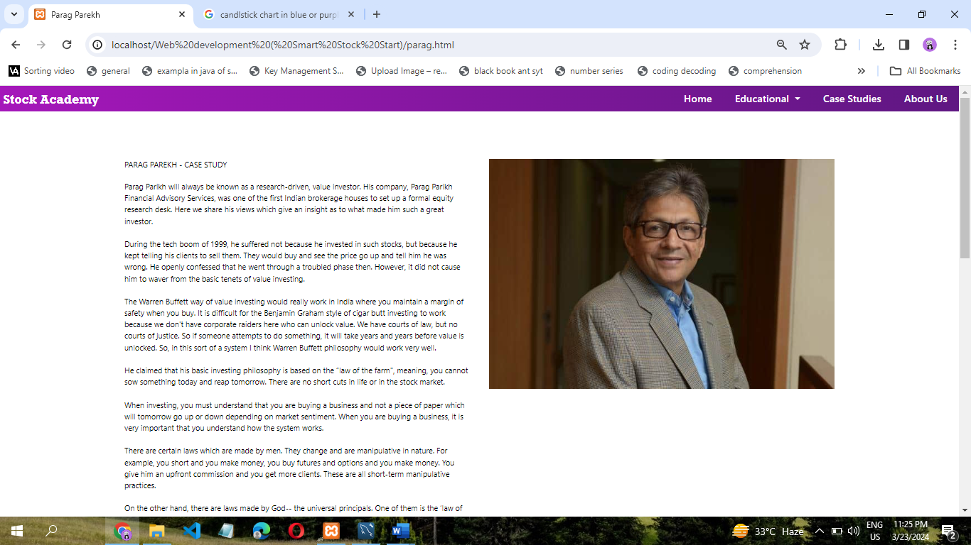

**Raamdeo Agrawal Page:**

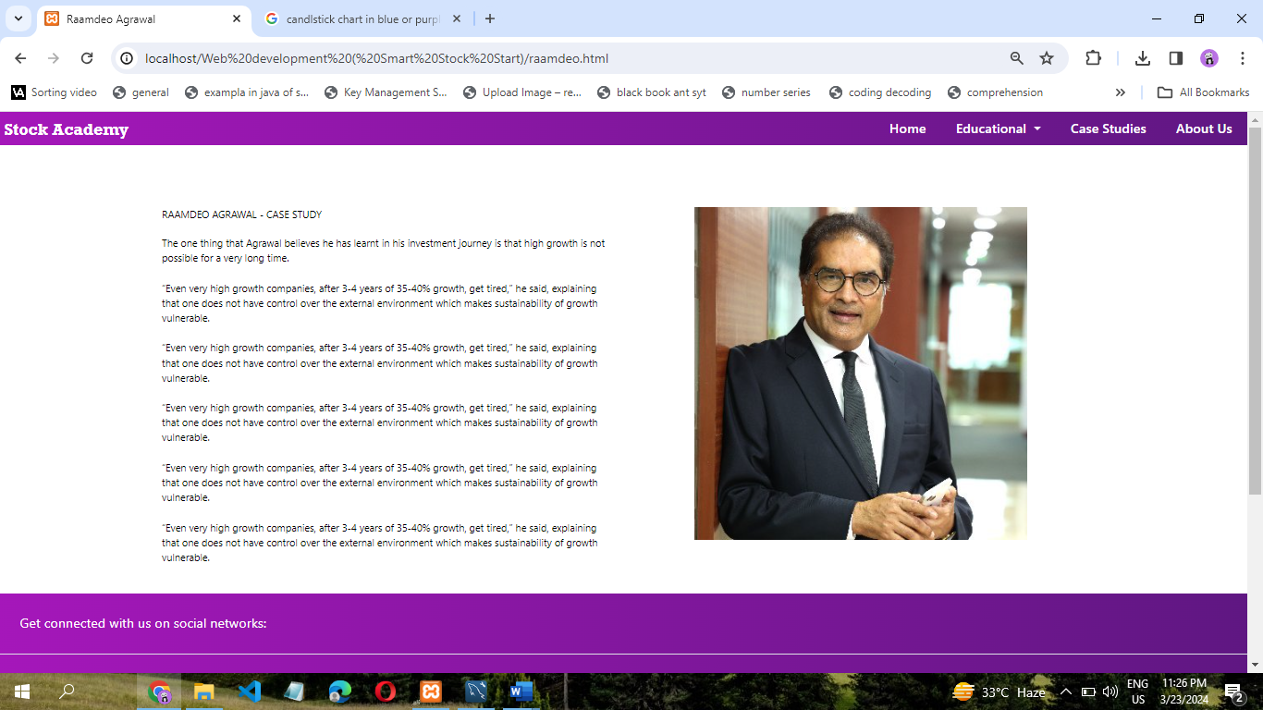

**4. About Us Page:**

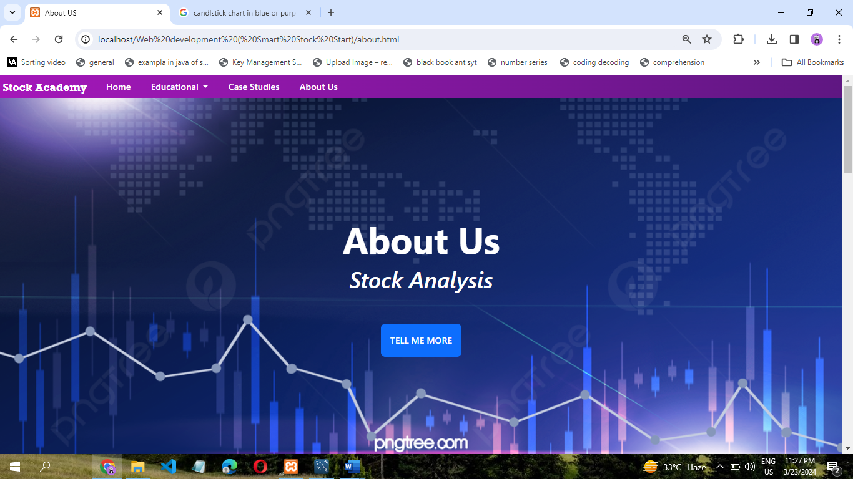

**TESTING AND**

**VALIDATION**

**CHECK**

**TESTING AND VALIDATION CHECKS**

Validation Testing, carried out by QA professionals, is to determine if the system complies with the requirements and performs functions for which it is intended and meets the organization’s goals and user needs. This kind of testing is very important, as well as verification testing. Validation is done at the end of the development process and takes place after verification is completed.

Thus, to ensure customer satisfaction, developers apply validation testing. Its goal is to validate and be confident about the product or system and that it fulfils the requirements given by the customer. The acceptance of the software from the end customer is also its part.

When software is tested, the motive is to check the quality regarding the found defects and bugs. When defects and bugs are detected, developers fix them. After that, the software is checked again to make sure no bugs are left. In that way, the software product’s quality scales up.

**TESTING PROCEDURE**

Testing phase was included on our project in order to get an idea when the errors located into our project. Testing is vital to the success of the system. System testing makes a logical assumption that if all the parts of the system are correct, the goal will be successfully achieved. Inadequate testing or non-testing leads to many errors that may not appear until months later.

This creates two problems:

1. The time lag between the causes and the appearance of the problem (the longer the time interval, the more complicated the problem has become)
2. The effect of the system errors on files and records within the system. A small system error can conceivably explode into a much larger problem.

**TESTING TECHNIQUES**

* **System Testing:** On our website, we have used this particular testing to ensure that the system is working correctly or not. It is a testing in which testing is done to check by accessing the website in a different environment is working or not.
* **Load Testing:** Load Testing is also known as performance testing which checks the overall performance of the project. In our project, we have also used this testing which helps us to check the system’s behavior under loads when more than one user is accessing the website simultaneously.
* **Stress Testing:** This particular testing is conducted to find the performance of the system in peak hours, it raises how much the system can face. We have done the testing of this project and we have seen that the website can work in any condition the only thing for the proper working is the Internet Connectivity.
* **Documentation Testing:** Documentation Testing is necessary for the project. It relies on finding out whether whatever document supplied is satisfactory or any further document should be supplied in the project. We have done documentation testing, so all the Content which are Written on the website is satisfactory for the user.

**SYSTEM SECURITY MEASURES**

##### SYSTEM SECURITY MEASURES

System security is the protection of information and property from theft, corruption, and other types of damage while allowing the information and property to remain accessible and productive. A security dashboard can be a vital tool for monitoring the health of your system's defenses.

##### SECURITY THREATS

1 . DATA LOSS:

Computer systems face a number of security threats. One of the basic threats is data loss, which means that parts of a database can no longer be retrieved. This could be the result of physical damage to the storage medium (like fire or water damage), human error, or hardware failures.

2 . HACKING:

Another security threat is unauthorized access. Many computer systems contain sensitive information, and it could be very harmful if it were to fall into the wrong hands. Imagine someone getting a hold of your social security number, date of birth, address, and bank information. Getting unauthorized access to computer systems is known as hacking.

3 . VIRUSES:

A third category of security threats consists of viruses and other harmful programs. A computer virus is a computer program that can cause damage to a computer's software, hardware or data. It is referred to as a virus because it has the capability to replicate itself and hide inside other computer files.

##### SECURITY MEASURES TO BE TAKEN

**1: Choose a Smart Password**

With there being so many websites, databases, and programs needing passwords, it is hard to keep track. A lot of people end up using the same password in all places, to remember their login information. Create a unique password for every new login request. Come up with complicated, random, and difficult-to-guess passwords. Then, store them outside the website directory.

**2 . Backup Of The Website**

One of the best methods to keep your site safe is to have a good backup solution. You should have more than one. Each is crucial to recovering your website after a major security incident occurs. Keep your website information off-site. Do not store your backups on the same server as your website; they are as vulnerable to attacks too. Choose to keep your website backup on a home computer or hard drive. Find an off-site place to store your data and protect it from hardware failures, hacks, and viruses.

**3 . Confidentiality**

Confidentiality is the protection of information in the system so that an unauthorized person cannot access it. This type of protection is most important in military and government organizations that need to keep plans and capabilities secret from enemies.

**IMPLEMENTATION EVALUATION**

**AND**

**MAINTENANCE**

##### IMPLEMENTATION, EVALUATION AND MAINTENANCE

**IMPLEMENTATION**

Implementation refers to the process of installing, configuring, and deploying software to a website. It involves taking the software application and making it operational on a web server, integrating it with other systems and software, and configuring it to work with the website's infrastructure.

In the context of a website, software implementation typically involves installing and configuring content management systems (CMS), e-commerce platforms, web analytics tools, or any other software that supports the website's functionality. This process may involve customizing the software to meet the specific needs of the website, integrating it with third-party applications and services, and configuring the necessary security measures to protect the website from threats.

The implementation process includes planning, and organizing. developing procedures, training the users, developing forms for data collection, developing files for storage of data, testing the system, cutover, and documenting the system. The process is further explained as such:

##### EVALUATION

After the implementation phase, another stage in project development is Evaluation. Evaluation during a program's implementation may examine whether the program is successfully recruiting and retaining its intended participants, using training materials that meet standards for accuracy and clarity, maintaining its projected timelines, coordinating efficiently with other ongoing programs and activities, and meeting applicable legal standards. Evaluation during program implementation could be used to inform mid-course corrections to program implementation (formative evaluation) or to shed light on implementation processes (process evaluation).

After keeping the project in the working condition for the sometime, all the errors that are showing in the computer program should be removed. The programmer needs to correct them so that same errors should not be repeated. We should also get the feedback from the user which are using it and ask them whether, it is user friendly or not. After evaluating the Program and satisfying the needs of the user the program is maintained.

While building and evaluating our project, we conclude that “HTML” is very basic an has very basic functionalities is build, and also it has high scope of development in the future.

##### MAINTENANCE

Maintenance of software can include software upgrades, repairs, and fixes of the software if it breaks.

Software applications often need to be upgraded or integrated with new systems the customer deploys. It's often necessary to provide additional testing of the software or version upgrades. During the maintenance phase, errors or defects may exist, which would require repairs during additional testing of the software. Monitoring the performance of the software is also included during the maintenance phase. Once the system is deployed, and customers start using the developed system, following 3 activities occur.

1. Bug fixing-

Bugs are reported because of some scenario which are not tested at all.

2 . Upgrade-

Upgrading the application to the newer versions of the Software.

3 . Enhancement -

Adding some new features into the existing software

**FUTURE SCOPE**

**OF THE PROJECT**

**FUTURE SCOPE OF THE PROJECT**

An informative website focusing on stock analysis for beginners can have a promising future scope, considering the growing interest in personal finance and investing among individuals. Here are some potential areas of growth and development for such a website:

**1 . Education and Learning Resources:** Continuously update and expand educational content tailored specifically for beginners. This could include articles, tutorials, videos, and interactive quizzes covering topics such as understanding stock market basics, interpreting financial statements, evaluating stocks, and managing investment risks.

**2 . User Engagement and Community Building:** Foster a community where beginners can ask questions, share experiences, and learn from each other. Incorporate features such as forums, discussion boards, and live chat support to encourage user interaction and engagement.

**3 . Customized Tools and Calculators:** Develop tools and calculators that help beginners analyze stocks, assess their risk tolerance, create investment portfolios, and track their investment performance. Providing easy-to-use tools can enhance the user experience and empower beginners to make informed investment decisions.

**4 . Market Analysis and Insights:** Offer timely market analysis, trends, and insights tailored for beginners. Provide explanations of key market events, economic indicators, and industry developments in a simple and understandable manner to help beginners navigate the complexities of the stock market.

**5 . Mobile-Friendly Platform:** Ensure that the website is optimized for mobile devices, as many users prefer accessing information on-the-go. Consider developing a mobile app to provide convenient access to educational content, tools, and community features.

**6 . Personalized Recommendations:** Implement algorithms that analyze user preferences, investment goals, and risk profiles to offer personalized stock recommendations and investment strategies. This can enhance user engagement and help beginners build confidence in their investment decisions.

**7 . Partnerships and Collaborations:** Collaborate with financial institutions, investment firms, and educational organizations to enhance the credibility and reach of the website. Partnering with experts and industry professionals can also enrich the content and provide valuable insights to beginners.

**8 . Monetization Strategies:** Explore various monetization strategies such as advertising, sponsored content, premium subscriptions, affiliate marketing, and premium educational courses. Diversifying revenue streams can help sustain the website's operations and fund further growth and development.

**9 . Continuous Improvement and Feedback:** Regularly solicit feedback from users to identify areas for improvement and refine the website's offerings. Stay updated on emerging trends, technologies, and regulatory changes in the financial industry to ensure the website remains relevant and valuable to beginners.

# CONCLUSION

##### CONCLUSION:

Concluding a stock analysis on an informative website typically involves summarizing the key findings and providing recommendations or insights for investors. provides valuable insights into its current standing and future prospects in the market. Through a thorough examination of various factors including financial performance, industry trends.

analysis provides valuable insights for both long-term and short-term investors. For long-term investors, our examination of the stock's fundamentals, including its revenue growth, profit margins, and competitive positioning, suggests a promising outlook. The company's consistent performance and robust financial health indicate potential for sustained growth over an extended period. Additionally, our case study illustrates successful investment outcomes for long-term holders who have capitalized on the stock's upward trajectory over time.

On the other hand, short-term investors can benefit from our analysis by leveraging market trends, technical indicators, and momentum strategies. By closely monitoring price movements, trading volumes, and key support and resistance levels, short-term traders can capitalize on short-lived opportunities for profit. Our case study highlights instances where astute short-term investors have generated significant returns by accurately timing their trades based on market dynamics and chart patterns.

Furthermore, our comprehensive analysis underscores the importance of a diversified investment approach. By incorporating both long-term and short-term strategies into their portfolio, investors can mitigate risk and optimize returns across different market conditions. Whether aiming for steady capital appreciation over time or exploiting short-term fluctuations for immediate gains, our research equips investors with the knowledge and tools necessary to make informed decisions.

In summary, our stock analysis provides actionable insights tailored to the diverse needs and preferences of investors. By considering both the long-term fundamentals and short-term market dynamics, individuals can devise well-rounded investment strategies aligned with their financial goals. Whether seeking to build wealth gradually through strategic long-term positions or capitalize on short-term opportunities for quick profits, our analysis serves as a valuable resource for navigating the complexities of the stock market and maximizing investment returns.

This conclusion summarizes the key points discussed in the stock analysis and provides a clear recommendation for investors, while also emphasizing the importance of conducting further research and seeking professional advice.

##### BIBLIOGRAPHY

##### AND

##### REFERENCES

##### BIBLIOGRAPHY AND REFERENCES

 You-tube

* 1. @CodeWithHarry

 Google

1 . https://mui.com/material-ui/

2 . <https://www.w3schools.com/>

3 . <https://www.geeksforgeeks.org/>

4 . https://getbootstrap.com/